**R Code for Examples in the book**

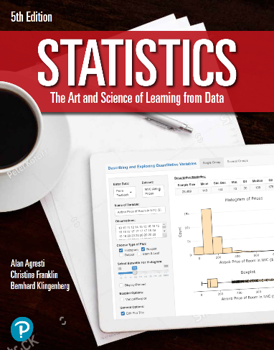

***“Statistics: The Art and Science of Learning from Data”***

**by Agresti, Franklin and Klingenberg, 5th edition**

**Chapter 15**

**Example 5: Frequent Dating and College GPA – Kruskal-Wallis Test**

## Reading in data

rare <- c(1.75, 3.15, 3.50, 3.68)  
occasional <- c(2.00, 3.20, 3.44, 3.50, 3.60, 3.71, 3.80)  
regular <- c(2.40, 2.95, 3.40, 3.67, 3.70, 4.00)  
y <- c(rare, occasional, regular)  
group <- rep(c('rare', 'occasional', 'regular'),   
 times = c(length(rare), length(occasional), length(regular)))

## To perform a Kruskal-Wallis test

kruskal.test(y ~ group)

##   
## Kruskal-Wallis rank sum test  
##   
## data: y by group  
## Kruskal-Wallis chi-squared = 0.72463, df = 2, p-value = 0.6961